Installation Guide For Ultimate QC

1. Go to https://www.mathworks.com.
2. If you do not already have one create and account:
   1. Click Log In.
   2. Click create an account.
3. Click on Products.
4. Click MATLAB:
   1. Scroll down and click get a trial.
   2. Download MATLAB with the Image Processing Toolbox and the Computer Vision System Toolbox.
5. Once installed contact the product owner for this project:
   1. Rodrigo Morales: rmorales@produceinspectors.com

to complete the activation of MATLAB.

* 1. He will send you the License File and File Installation Key along with instructions to complete the activation.

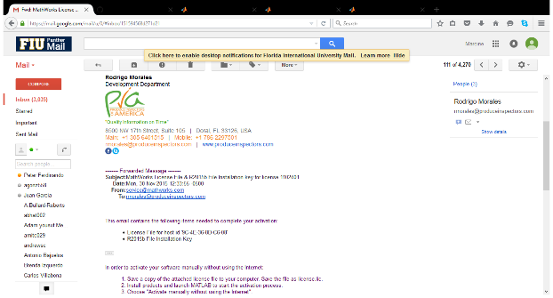 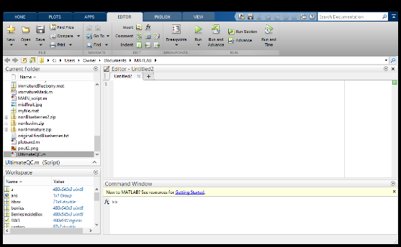

1. Once MATLAB has been activated with the Image Processing and Computer Vision System Toolboxes installed:
   1. Go to https://github.com/FIU-SCIS-Senior-Projects/Ultimate-QC.
   2. Click Download Zip.
   3. Download the files into your MATLAB folder and unzip them.
   4. You should be able to see the files under the Current Folder of the MATLAB application.

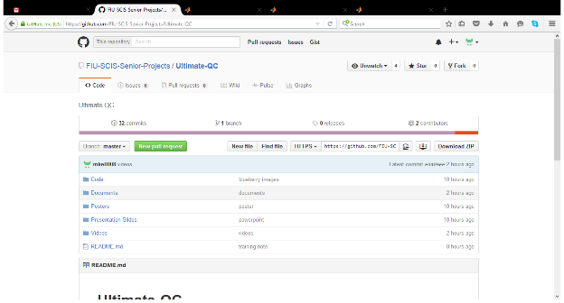 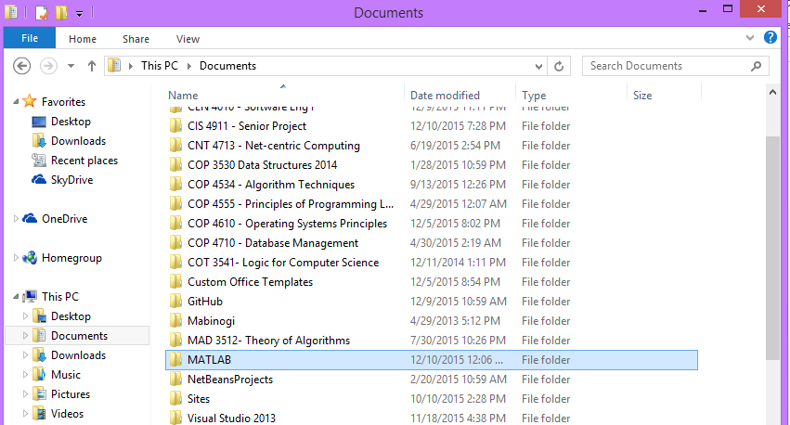

1. On https://www.mathworks.com you will find documentation for MATLAB, the Image Processing Toolbox, and the Computer Vision System Toolbox with guides, examples and functions to help you get started.
2. See User Manual.
3. Helpful links:
   1. http://www.mathworks.com/help/matlab/
   2. http://www.mathworks.com/help/images/
   3. http://www.mathworks.com/help/vision/